

Specification

E/One Sentry Advisor
Remote Monitoring
Panel Option

Standalone Version
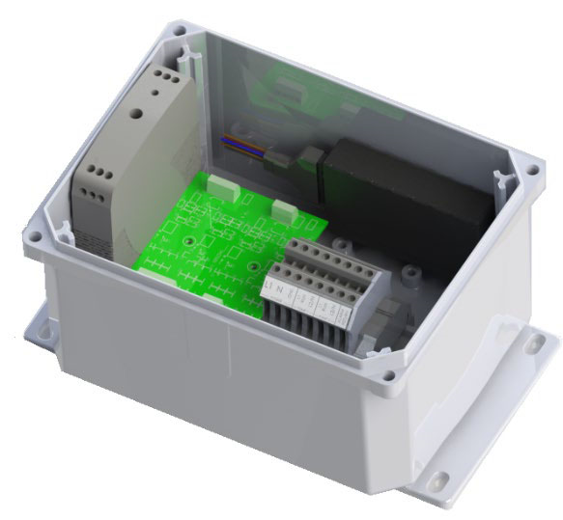

OPTION FOR GRINDER PUMP MONITORING

(OPTIONAL) A Standalone Wireless Cellular Based Communication Package for use in monitoring grinder pump type sewage collection systems – The E/One Sentry Advisor Standalone Option uses a cellular transmitter to communicate Trouble conditions and high level alarms. Each standalone panel shall be equipped with hardware that interfaces with the necessary signals for high level alarm and pump running events. This information shall then be transmitted to a host system that utilizes an interactive website interface for end users to access the information.

A secure user ID and password shall be used to provide access to the website. The website shall quickly identify sites that may be experiencing trouble and shall be able to generate reports including: running tallies of usage, flow rates, potential infiltration, predictive maintenance indicators, and asset mapping/management. The website shall also provide a means to configure alerts corresponding to the various Trouble conditions that can be sent to users via secure e-mail, SMS text, phone or an existing telemetry system. These alerts can be sent to any number of recipients.

Accessible data shall include:
- Pump Runtime
- Pump Cycles
- Min, Max, Avg. and Last Runtime
- Trouble Events
  - High Level Alarm
  - Excessive Runtime
- Average GPM based Flow Rate Data

The E/One Sentry Advisor Standalone Option shall be equipped with a battery that will allow one message to be sent out in the event of a power loss.

The communication package shall be a factory prewired unit in a small, NEMA 4X enclosure, including the compact cellular transmitter, power supply and antenna. The E/One Sentry Advisor Standalone Option shall be mounted by others in close proximity of the grinder pump alarm panel and shall include a wiring harness provided by the manufacturer and installed by others. Systems with this option must be within range of the associated cellular network.

ENCLOSURE: Each E/One Sentry Advisor Standalone Assembly shall include a UL Listed, NEMA 4X Polycarbonate enclosure. The enclosure is not to exceed 9.7 inches wide x 6.5 inches high x 5.4 in deep. It shall be equipped with tamper proof screws for security.



Environment One Corporation
2773 Balltown Road
Niskayuna, New York 12309
www.eone.com
A Precision Castparts Company

LM000451 Rev –

