

Specification

E/One T260 Alarm Panel
for Quadplex Stations
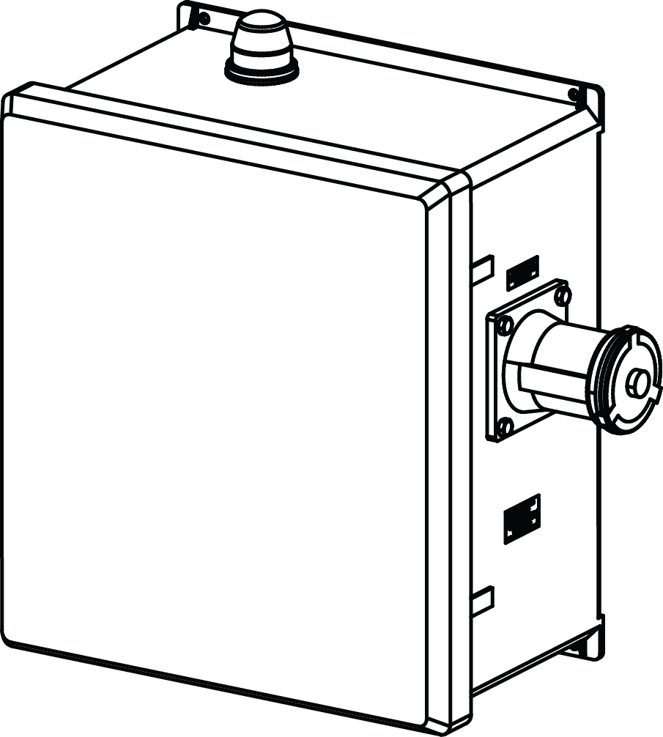

QUADPLEX STATIONS

MOD T260 QUADPLEX:

Each grinder pump station shall include a NEMA 4X, UL-listed alarm panel suitable for wall or pole mounting. The NEMA 4X enclosure shall be manufactured of thermoplastic or fiberglass to ensure corrosion resistance. The enclosure shall include a hinged, lockable cover with padlock, preventing access to electrical components, and creating a secured safety front to allow access only to authorized personnel. The standard enclosure shall not exceed 12.5" W x 16" H x 7.5" D.

The panel shall contain one 15-amp single pole circuit breaker for the alarm circuit and one 15-amp double pole circuit breaker per core for the power circuit. The panel shall contain a push-to-run feature for each pump core, an internal run indicator, and a complete alarm circuit. All circuit boards in the alarm panel are to be protected with a conformal coating on both sides and the AC power circuit shall include an auto resetting fuse.

The visual alarm lamp shall be inside a red, round lens at least 2.25 in diameter x 2.0" H. Visual alarm shall be mounted to the top of the enclosure in such a manner as to maintain the NEMA 4X rating. The audible alarm shall be externally mounted on the bottom of the enclosure, capable of 93 dB @ 2 feet. The audible alarm shall be capable of being deactivated by depressing a push-type switch that is encapsulated in a weatherproof silicone boot and mounted on the bottom of the enclosure (push-to-silence button).

The high-level alarm system shall operate as follows:
- The panel will go into alarm mode if any pump’s alarm switch closes. During the initial alarm mode, all pumps will run and the alarm light and buzzer will be delayed for a period of time based on user settings (default is 3-1/2 minutes). If the station is still in high level alarm after the delay, the light and buzzer will be activated.
- The audible alarm may be silenced by means of the externally mounted push-to-silence button.
- The visual alarm remains illuminated until the sewage level in the wet well drops below the “off” setting of the alarm switch for all pumps.

The entire alarm panel, as manufactured and including any of the following options, shall be listed by Underwriters Laboratories, Inc.

Generator Receptacle and Auto Transfer – The alarm panel shall include a minimum 60 amp, 250 VAC generator receptacle with a spring-loaded or screw-on, gasketed cover suitably mounted to provide access for connection of an external generator while maintaining a NEMA 4X rating. An automatic transfer switch shall be provided, which switches from AC power to generator power automatically. Power shall be provided to the alarm panel through the generator receptacle whenever power is present at the receptacle, allowing the audible and visual alarms to function normally in generator mode. When power is no longer applied to the generator receptacle, the panel is automatically switched back to the AC Mains power. (No manual switching within the panel enclosure is necessary to switch from generator power back to AC Mains, so the mode cannot be inadvertently left in the generator position after pumping down the station in generator mode, as is the case with a manual transfer switch).

(OPTIONAL) Remote Sentry Indoor Alarm Module – A separate, remote indoor alarm module shall be provided to indicate a high level alarm with or without AC power to the grinder pump station. The Remote Sentry indoor alarm module shall have an internal power source enabling its continued operation without AC power. The Remote Sentry shall have an audible alarm and a visual alarm, both of which shall automatically reset if the high level alarm condition is eliminated. The Remote Sentry indoor alarm module shall include a Silence button for the audible alarm and a Test button.

(OPTIONAL) Run-time/Hour Meter – A run-time or hour meter to display the total run-time or operation time for the pump cores shall be provided.

(OPTIONAL) Wireless Cellular Based Communication Package – The E/One Sentry Advisor uses a cellular transmitter to communicate Trouble conditions and high level alarm. Each panel shall be equipped with hardware that is connected to dry contacts for high level alarm and pump running events. This information shall then be transmitted to a host system that utilizes an interactive website interface for end users to access the information.

A secure user ID and password shall be used to provide access to the website. The website shall quickly identify sites that may be experiencing trouble and shall be able to generate reports including: running tallies of usage, flow rates, potential infiltration, predictive maintenance indicators and asset mapping/management. The website shall also provide a means to configure alerts corresponding to the various trouble conditions that can be sent to users via secure e-mail, SMS text, phone or an existing telemetry system. These alerts can be sent to any number of recipients.

Accessible data shall include:
- Pump Run Time
- Pump Cycles
- Minimum, Maximum, Average and Last Run Time
- Trouble Events
  - High Level Alarm
  - Excessive Run Time
- Average GPM based Flow Rate Data
The E/One Sentry Advisor shall be equipped with a battery that will allow one message to be sent out in the event of a power loss.

The communication package shall be a factory-prewired unit within the panel enclosure, including the compact cellular transmitter, power supply and antenna. Panels with this option must be within range of the associated cellular network.



Environment One Corporation
2773 Balltown Road
Niskayuna, New York 12309
www.eone.com
A Precision Castparts Company

LM000440

