

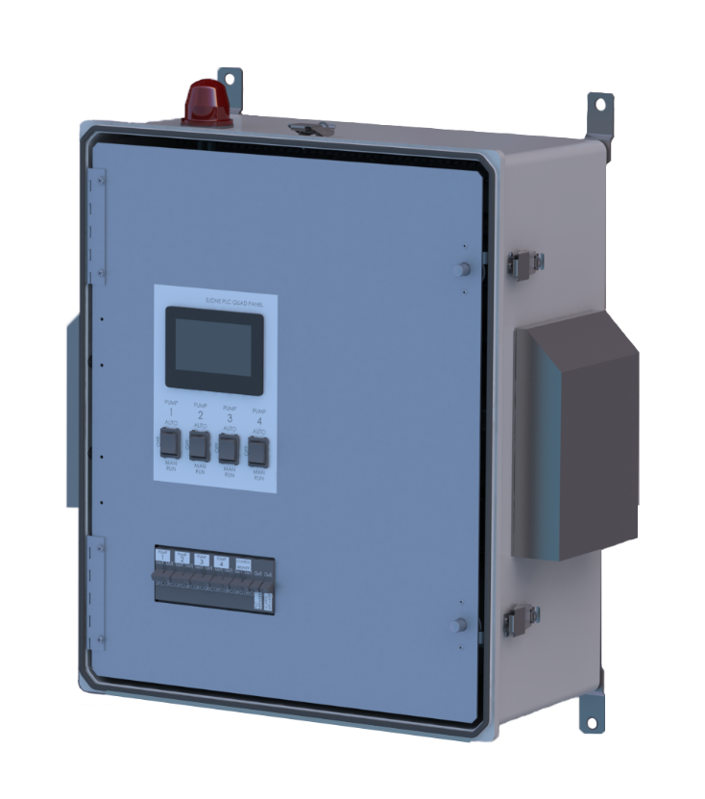

Specification

E/One PLC Multiplex Sequencing Alarm Panel

MULTIPLEX STATIONS

The E/One PLC Multiplex Sequencing Panel shall be designed to control one to four (1-4) E/One Manual Pumps using input from a pressure transducer and shall utilize predictive alarms to notify operators of potential pending service requirements.

Each Multiplex Station shall include a NEMA 4X, UL-listed alarm panel suitable for wall or pole mounting. The NEMA 4X enclosure shall be manufactured of fiberglass to ensure corrosion resistance. The enclosure shall include a hinged, lockable cover with padlock, preventing access to electrical components, and creating a secured safety front to allow access only to authorized personnel. The standard enclosure shall not exceed 20" W x 24" H x 10" D and will include a Hinged, Aluminum Deadfront.

The panel shall contain one 15-amp single pole circuit breaker for the alarm circuit, 1 15-amp single pole circuit breaker for PLC, one 15-amp double pole circuit breaker per core for the power circuit, and 1 15-amp double pole circuit breaker for the control circuit.

The visual alarm lamp shall be inside a red lens. Visual alarm shall be mounted to the top of the enclosure in such a manner as to maintain NEMA 4X rating. The audible alarm shall be externally mounted on the bottom of the enclosure, capable of 93 dB @ 2 feet. The audible alarm shall be capable of being deactivated by depressing a push-type switch that is encapsulated in a weatherproof silicone boot and mounted on the bottom of the enclosure (push-to-silence button) in such a manner as to maintain NEMA 4X rating.

The PLC Panel shall include the following specific features:
- The touch screen controller interface shall display pump status, operating conditions, operating parameters and shall provide for operator interaction. The following messages will be displayed on the touch screen interface in the active alarm log or alarm history to indicate various system conditions:
  - HIGH FLUID LEVEL – indicates a high level is present per high level float or transducer
  - LOW FLUID LEVEL – indicates a low level is present per low level float or transducer
  - LOW VOLTAGE – indicates the AC mains voltage feeding a pump is below the minimum limit
  - HIGH VOLTAGE – indicates the AC mains voltage feeding a pump is above the maximum limit
  - P1/2/3/4 OVERPRESSURE – indicates a pumps current draw is above the maximum limit
  - P1/2/3/4 OP PERMALOCK – indicates a pump has been locked out due to repeated overpressure states
  - P1/2/3/4 RUN LIMIT – indicates a pump runtime has exceeded the limit set under the Run Limit setting
  - BLOCKED LINE – indicates that all pumps are locked out due to overpressure conditions
  - P1/2/3/4 FAILED TO START – indicates that a pump failed to start when called to run by the PLC
  - C1/2/3/4 FAULT – indicates that a contactor failed to close when called by the PLC, or failed to open when not called by the PLC, and not being manually run
- Pump data readout: cycle count, pump current and voltage, total runtime, fluid level, hand/auto and latched fault conditions
- Pressure transducer shall provide real-time fluid level readout to the interface
- High and low level floats shall be used as backups to pressure transducer
- Editable run & alarm levels (run level 1, 2, 3, 4 and alarm)
- Editable trouble condition set points (overpressure)
- Pump sequencing shall be based on runtime and fluid level in order to:
  - Keep wear and tear even by keeping runtimes equal
  - Give all available pumps an opportunity to run before alarm level is reached
  - Allow lead - lag relationships to be determined dynamically based on runtime
  - Sequencing logic shall allow disabled pumps to be skipped
- "Next to Run" indicator
- Manual trouble condition reset
- Last run time
- Min/avg/max runtime
- Min/avg/max current
- Min/avg/max voltage
- Run limit trouble condition
- Alarm test via touch screen
- Restore factory default set points via touch screen
- Cycles of each pump core
- Cold start via touch screen – resets pump performance data
- Panel wiring shall be “tidy” through the use of wire ducts
- Hinged aluminum dead-front and aluminum back plate
- External audible and visual alarm
- Manual alarm silence
- Manual run

- Trouble indications:
  - Pump Overpressure Condition – Pump operating at abnormally high current level
  - Brownout Condition – Mains voltage 12% below nameplate rating
  - Overvoltage Condition – Mains voltage 12% above nameplate rating
  - High Liquid Level
  - Low Liquid Level
  - Real-time, High, and Low Voltage on the input
  - Real-time and High current drawn by the Pump
  - Pump failed to start
  - Contactor fault
  - Loss of Communication

- Protection feature – The panel shall disable pumps based on the following conditions in order to prevent it from running in adverse conditions:
  - Pump overpressure condition – locks out the pump that experienced the condition for 20 minutes before resetting
  - After 3 lockouts due to overpressure the next overpressure condition shall lock out the pump until service personnel clear the condition
  - If all pumps experience an overpressure condition at the same time the panel shall lock out all pumps to prevent damage to the system until service personnel clear the condition
  - Brownout – Disables all pumps until voltage returns to an acceptable level (see above)
  - Overvoltage – Disables all pumps until voltage returns to an acceptable level (see above)

- Padlock
- Alarm history log
- Real time pump performance
- NEMA 4X enclosure, polycarbonate, 24"H x 20"W x 10"D
- Enclosure options:
  - Stainless steel
  - Cooling fan
For safety reasons, the entire alarm panel, as manufactured, shall be listed by Underwriters Laboratories, Inc.



Environment One Corporation
2773 Balltown Road
Niskayuna, New York 12309
www.eone.com
A Precision Castparts Company

LM000450 Rev B
07/06/2021

