

Air Release Station (Model ARS)

Typical Specifications

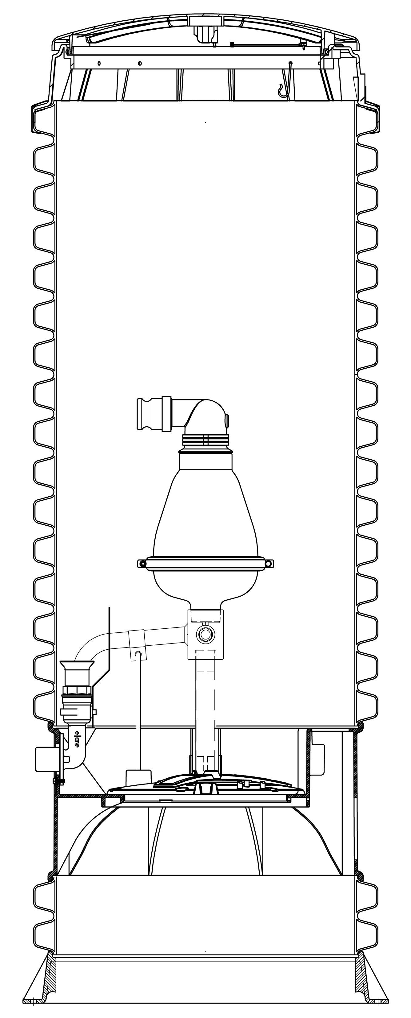

SECTION: COMBINATION AIR RELEASE VALVE STATIONS

1.0 General

1.01 GENERAL DESCRIPTION: The MANUFACTURER shall furnish complete factory-built and tested Combination Air Release Valve Station(s), each consisting of a stainless steel manifold for mounting a factory provided 2” Male NPT Combination Air Valve suitably mounted in an HDPE Tank. The air valve itself may also be provided by others. The tank and manifold shall feature a quick disconnect feature that enables the valve to be removed from the top of the tank (at grade level) without entering the tank, conforming to OSHA Confined Space Standards.

1.02 SUBMITTALS: After receipt of notice to proceed, the MANUFACTURER shall furnish a minimum of five sets of shop drawings detailing the equipment to be furnished including dimensional data and materials of construction. The ENGINEER shall promptly review this data, and return two copies as accepted, or with requested modifications. Upon receipt of accepted shop drawings, the MANUFACTURER shall proceed immediately with fabrication of the equipment.

1.03 MANUFACTURER: The MANUFACTURER of the Combination Air Release Valve Station shall be Environment One Corporation or approved equal.

1.04 WARRANTY: The valve station MANUFACTURER shall provide a part(s) and labor warranty on the tank and valve manifold for a period of 12 months after shipment. Any manufacturing defects found during the warranty period will be reported to the MANUFACTURER by the OWNER and will be corrected by the MANUFACTURER at no cost to the OWNER. The Air Release Valve itself carries the actual VALVE MANUFACTURER’S standard warranty, which will be in effect through the VALVE MANUFACTURER.

2.0 PRODUCT

2.01 COMBINATION AIR VALVE: The air release valve shall be a 2” Male NPT combination air valve that will act as an air release valve by allowing accumulated/entrapped air in the force main to escape as well as provide vacuum relief when needed. The valve shall include an inlet, outlet, body, cover, float and lever mechanism, orifice and seat. The valve shall be a single body standard combination valve designed specifically for sewage applications.

2.02 TANK: High Density Polyethylene Construction (HDPE). The tank shall be an open bottom wetwell design made of high density polyethylene of a grade selected for environmental stress cracking resistance. Corrugated sections are to be made of a double wall construction with the internal wall being generally smooth. Corrugations of the outside wall are to be of a minimum amplitude of 1-1/2" to provide necessary transverse stiffness. Any incidental sections of a single wall construction are to be a minimum .250 inch thick. All seams created during tank construction are to be thermally welded and factory tested for leak tightness. Tank wall must withstand the pressure exerted by saturated soil loading at maximum burial depth. All station components must function normally when exposed to maximum external soil and hydrostatic pressure.

The tank shall include a lockable cover assembly providing low profile mounting and watertight capability. The cover shall be high density polyethylene, green in color, with a load rating of 150 lbs per square foot. The cover assembly shall also include an integral 2-inch vent to prevent sewage gases from accumulating in the tank. The accessway design and construction shall facilitate field adjustment of station height in increments of 3" or less without the use of any adhesives or sealants requiring cure time before installation can be completed.

The station shall have all necessary penetrations factory sealed and tested. No field penetrations shall be acceptable. The Tank shall have a stainless steel bulkhead for connection to the force main which terminates outside the tank wall with a 1-1/4" female pipe thread. The bulkhead shall be factory installed and warranted by the manufacturer to be watertight.

Consult the contract drawings for station tank heights.
2.03 AIR RELEASE PIPING AND DISCONNECT VALVE: All valve manifold fittings and piping shall be constructed from 304 Stainless steel and shall be factory assembled. The valve inlet manifold shall also include a ¼” stainless steel bleed off valve for ease of service. The tank shall include a 1-1/4” stainless steel ball valve rated for 235 psi WOG with a quick disconnect feature to simplify installation and valve removal. The bulkhead penetration of this valve shall be factory installed and warranted by the manufacturer to be watertight and shall terminate outside the accessway bulkhead with a stainless steel, 1-1/4” female NPT fitting. PVC ball valves or brass ball/gate valves will not be accepted.

2.04 SERVICEABILITY: The valve shall have two lifting hooks complete with lift-out harness connected to its bottom housing to facilitate easy valve removal when necessary. All mechanical connections must provide easy disconnect capability for valve removal and installation.

2.05 OSHA CONFINED SPACE: All maintenance tasks for the valve station must be possible without entry into the tank (as per OSHA 29 CFR 1910.146 permit-required confined spaces). “Entry means the action by which a person passes through an opening into a permit-required confined space. Entry includes ensuing work activities in that space and is considered to have occurred as soon as any part of the entrant’s body breaks the plane of an opening into the space.”

3.0 EXECUTION

3.01 FACTORY TEST: Each valve shall be factory tested for proper operation.

3.02 DELIVERY: All valve stations will be delivered to the job site 100 percent completely assembled, including testing, ready for installation. The tanks of taller stations may be shipped in two pieces in order to fit on a truck. These taller tanks require a field joint to be assembled on site by the CONTRACTOR (consult contract drawings for additional details). The tank and valve inlet manifold piping may also be dropped shipped for use with an existing or new 2” Male NPT Air Release Valve provided by others.

3.03 TANK INSTALLATION: Earth excavation and backfill are specified under SITE WORK, but are also to be done as a part of the work under this section, including any necessary sheeting and bracing.

Installation shall be in strict accordance with station and valve manufacturers’ recommendations.

The CONTRACTOR shall be responsible to provide a firm, dry subgrade for the structure.

The valve stations shall not be set into the excavation until the installation procedures and excavation have been approved by the ENGINEER.

Remove packing material. User instructions MUST be given to the OWNER. Hardware supplied with the unit, if required, will be used at installation. The basin may not be dropped, rolled or laid on its side for any reason.

Installation shall be accomplished so that 1" to 4" of accessway, below the bottom of the lid, extends above the finished grade line. The finished grade shall slope away from the unit.

A 12" inch (minimum) layer of naturally rounded aggregate, clean and free flowing, with particle size of not less than 1/8" or more than 3/4" shall be used as bedding material under each unit. The ENGINEER shall make the final bedding determination based on field conditions.

3.04 BACKFILL REQUIREMENTS: Proper backfill is essential to the long-term reliability of any underground structure. Several methods of backfill are available to produce favorable results with different native soil conditions. The most highly recommended method of backfilling is to surround the unit to grade using Class I or Class II backfill material as defined in ASTM 2321. Class 1A and Class 1B are recommended where frost heave is a concern; Class 1B is a better choice when the native soil is sand or if a high, fluctuating water table is expected. Class 1, angular crushed stone, offers an added benefit in that it doesn’t need to be compacted.

Class II, naturally rounded stone, may require more compactive effort, or tamping, to achieve the proper density. If the native soil condition consists of clean compactible soil, with less than 12% fines, free of ice, rocks, roots and organic material, it may be an acceptable backfill. Soil must be compacted in lifts not to exceed one foot to reach a final Proctor Density of between 85% and 90%. Heavy, non-compactable clays and silts are not suitable backfill for this or any underground structure.

If you are unsure of the consistency of the native soil, it is recommended that a geotechnical evaluation of the material is obtained before specifying backfill.

Another option is the use of a flowable fill (i.e., low slump concrete). This is particularly attractive when installing valve stations in augured holes where tight clearances make it difficult to assure proper backfilling and compaction with dry materials. Flowable fills should not be dropped more than four feet from the valve station inlet to the bottom of the hole to avoid separation of the constituent materials.

Backfill of clean, native earth, free of rocks, roots, and foreign objects, shall be thoroughly compacted in lifts not exceeding 12" to a final Proctor Density of not less than 85%. Improper backfilling may result in damaged accessways. The valve station shall be installed at a minimum depth from grade to the top of the 1 1/4" valve inlet line, to assure maximum frost protection. The finish grade line shall be 1" to 4" below the bottom of the lid, and final grade shall slope away from the valve station.

All restoration will be the responsibility of the CONTRACTOR. Per-unit costs for this item shall be included in the CONTRACTOR’S bid price for the individual valve station. The properties shall be restored to their original condition in all respects, including, but not limited to, curb and sidewalk replacement, landscaping, loaming and seeding, and restoration of the traveled ways, as directed by the ENGINEER.

END OF SECTION



Environment One Corporation
2773 Balltown Road
Niskayuna, New York 12309
www.eone.com
A Precision Castparts Company

LM000385 Rev B

